#One sample t-test prototype

#Justin Mann

#2/17/2016

**#A one sample t-test tests hypotheses about the mean of a population with unknown variance.**

**#Assumptions:**

#1. Observed values, x1-xn, are a random sample from a normally distributed population.

#2. Variance of the population is unknown

##Note: this test is robust for deviations from a normal distribution

**#Hypotheses:**

#Null: Mu equals mu_naught

#Alternative: Mu does not equal mu_naught

#I will run a t-test on a subset of the iris data (built into R), setosa sepal length.

#Read table

iris

#Assign data subset

x <- iris$Sepal.Length[iris$Species=="setosa"]

x

#Visually verify normal distribution of "x"

hist(x)

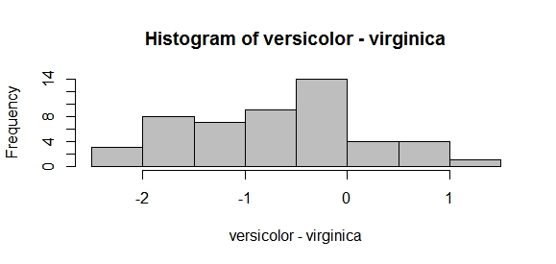

#Verify length and assign

n <- length(x)

n

#Assign population mean

Mu <- 5

Mu

#Assign sample mean

xbar <- mean(x)

xbar

#Assign stardard deviation of x

s <- sqrt(var(x))

s

#*****Test Statistic*****

t <- (xbar-Mu)/(s/sqrt(n))

t

**[1] 0.1203621**

#Critical Value of the Test:

alpha <- 0.05

degf <- n-1

degf

**[1] 49**

C1 <- qt(alpha/2,degf)

C1

**[1] -2.009575**

C2 <- qt(1-alpha/2,degf)

C2

**[1] 2.009575**

#Decision Rule:

#if t<C1 or if t>C2, then reject Null

#if abs(t)>abs(C), then reject Null

#Probability (P) Value (two sided case)

Pa <- 2 * pt(t,degf)

Pa

**[1] 1.095312**

Pb <- 2*(1-pt(t,degf))

Pb

**[1] 0.9046885**

#Confidence Interval for the Mean

CI1 <- xbar+abs(C1)*(s/sqrt(n))

CI1

**[1] 5.106176**

CI2 <- xbar-abs(C1)*(s/sqrt(n))

CI2

**[1] 4.905824**

#Run test with R function "t.test"

t.test(x, alternative="two.sided", mu=0, conf.level=0.95)

**One Sample t-test**

**data: x**

**t = 100.42, df = 49, p-value < 2.2e-16**

**alternative hypothesis: true mean is not equal to 0**

**95 percent confidence interval:**

**4.905824 5.106176**

**sample estimates:**

**mean of x**

**5.006**

#####One Tail Case(Lower Tail)######

#Assumptions: same as two-tailed

#Hypotheses:

#Null: Mu is greater than or equal to Mu_naught

#Alternative: Mu is less than Mu_naught

#*****Test Statistic*****

t <- (xbar-Mu)/(s/sqrt(n))

t

#Critical Value of the test:

alpha <- 0.05

degf <- n-1

degf

C <- qt(alpha, degf)

C

#Decision Rule: if t<C, then reject the Null.

#Probability Value:

P <- pt(t,degf)

P

#Confidence Interval for the Mean:

CI1 <- xbar+abs(C1)*(s/sqrt(n))

CI1

#Lower Tail Case built-in R function

t.test(x,alternative="less", mu=0,conf.level=0.95)

#####One Tail Case (Upper Tail)#####

#Assumptions: same as two-tailed

#Hypotheses:

#Null: Mu is less than or equal to Mu_naught

#Alternative: Mu is greater than Mu_naught

#*****Test Statistic*****

t <- (xbar-Mu)/(s/sqrt(n))

t

#Critical Value of the test:

alpha <- 0.05

degf <- n-1

degf

C <- qt(alpha, degf)

C

#Decision Rule: if t<C, then reject the Null.

#Probability Value:

P <- pt(t,degf)

P

#Confidence Interval for the Mean:

CI1 <- xbar-abs(C1)*(s/sqrt(n))

CI1

#Upper Tail Case built-in R function

t.test(x,alternative="greater", mu=5,conf.level=0.95)